## Measure Your Impact

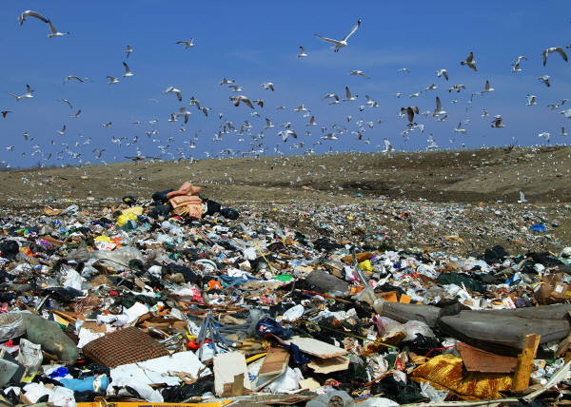

Shorten your shower by two minutes and save 342 lbs. in CO2 emissions.

Replace one incandescent bulb with a compact fluorescent light bulb (CFL) and save approximately 55 lbs.

Use an Energy Star refrigerator and save 500 lbs.

Recycle paper, plastic, and glass and save over 1,000 lbs.

Replace red meat in your diet with fish, eggs, and poultry to save over 950 lbs.

Wash at least half your laundry in cold water and save 72 lbs.

Hang half your laundry to dry and save 723 lbs.

Plug your home entertainment devices into a power strip and turn it off when not in use to save 240 lbs.

Lower your thermostat one degree below 70° to save 320 lbs. for natural gas heat and 236 lbs. for electrical heat.

Raise your air conditioning thermostat one degree above 72° to save 121 lbs.

Seal air-leaking cracks in your home to save up to 639 lbs.

Lower your water temperature from 140° to 120° to save 479 lbs.

Take public transportation instead of driving for an average savings of 1,366 lbs. for a 12-mile commute.